**3. Design files**

Design files summary.

| **Design file name** | **File type** | **Open source license** | **Location of the file** |
| --- | --- | --- | --- |
| eGH_Sensor_Package | .ino |  |  |
| Config | .h |  |  |
| eGreenhouseJSON | .cpp |  |  |
| eGreenhouseJSON | .h |  |  |
| eGreenhouse | .pde |  |  |
| Timer | .pde |  |  |
| Hub_Receive | .ino |  |  |
| Config | .h |  |  |
| eGreenhouseJSON | .cpp |  |  |
| eGreenhouseJSON | .h |  |  |
| Hub_Transmit | .ino |  |  |
| config | .h |  |  |
| hyperJSON | .cpp |  |  |
| hyperJSON | .h |  |  |
| HyperDrive | .ino |  |  |
| config | .h |  |  |
| hyperJSON | .cpp |  |  |
| hyperJSON | .h |  |  |
| Layout for eGreenhouse System | .png |  |  |
| eGreenhousePCBpowerboost | .brd |  |  |
| eGH Sensor Package222 | .png |  |  |
| eGH Sensor Packagev5 | .png |  |  |
| K30_1 | .jpg |  |  |
| K30_Layout | .png |  |  |
| TSL2591 | .jpg |  |  |
| SHT31-D | .jpg |  |  |
|  |  |  |  |

**Hub_Transmit**: INO file used for gathering User Input from eGreenhouse.pde then send to HyperDrive.

**HyperDrive:** INO file used for moving the HyperRail from User Input and send values and indication to start measure to the eGH_Sensor_Package.

**eGH_Sensor_Package:** INO file used for measuring K30, SHT31-D, and TSL2591 then log to SD card and send values to the Hub_Receive.

**Hub_Transmit**: INO file used for gathering User Input from eGreenhouse.pde then send to HyperDrive.

**Hub_Receive**: INO file used for receiving sensor values and coordinates, then publish to GoogleSheets.

**config:** H files used for all INO file: for eGH_Sensor_Package, Hub_Transmit, Hub_Receive, HyperDrive.

**eGreenhouse**: PDE file that is used for the GUI that take User Input

**Timer**: PDE file that enable a built in timer for the GUI.

**eGreenhouseJSON**: CPP and H files using for both eGH_Sensor_

**eGreenhousePCBpowerboost:** BRD file used for layout of the sensor location.

**eGH Sensor Package222:** PNG file used for the top view of the eGreenHouse_Sensor_Collector.

**eGH Sensor Packagev5:** PNG file used for the side view of the eGreenHouse_Sensor_Collector.

**K30_1:** JPG file used for the top view of the K30 CO2 sensor.

**K30_Layout:** JPG file used for indication of wire connection between MO board and K30 CO2 sensor.

**TSL2591:** JPG file used for indication of wire connection between MO board and TSL2591 light sensor.

**SHT31-D:** JPG file used for indication of wire connection between MO board and SHT31-D temperature and humanity sensor.

<https://ctemps.org/opens-lab-environmental-sensing>

**4. Bill of materials**

Materials for eGH_Sensor_Package

| **Designator** | | **Component** | **Number** | **Cost per unit** | **Total cost** | **Source of materials** | **Material** |
| --- | --- | --- | --- | --- | --- | --- | --- |
| Development  Board | | Adafruit Feather M0 with RFM95 LoRa Radio - 900MHz - RadioFruit | 1 | $34.95 | $34.95 | Adafruit | Non-specific |
| Antenna Kit | 900Mhz Antenna Kit - For LoPy, LoRa, etc | | 1 | $12.75 | $12.75 | Adafruit | Non-specific |
| Antenna Connector | uFL SMT Antenna Connector | | 1 | $0.75 | $0.75 | Adafruit | Non-specific |
|  | |  |  |  |  |  |  |
| Data Logger  and RTC | | Adalogger FeatherWing - RTC + SD Add-on For All Feather Boards | 1 | $8.95 | $8.95 | Adafruit | Non-specific |
| Micro SD Card | | 16 GB MicroSD Card | 1 | $7.00 | $7.00 | Amazon | Non-specific |
| CO2 Sensor | | K30 10,000ppm CO2 Sensor | 1 | $85.00 *** | $85.00 | CO2Meter | Non-specific |
| Light Sensor | | Adafruit TSL2591 High Dynamic Range Digital Light Sensor | 1 | $6.95 | $6.95 | Adafruit | Non-specific |
| Temperature  and Humidity  Sensor | | Adafruit Sensirion SHT31-D - Temperature & Humidity Sensor | 1 | $13.95 | $13.95 | Adafruit | Non-specific |
| Sensor PCB | | Custom Component | 1 |  |  |  |  |
| Coin Cell Battery | | 1220, Button Cell Battery, Lithium, 3VDC, Diameter 0.472", Depth 0.078" | 1 | $0.68 | $0.68 | Grainger | Non-specific |
| Board Headers | | Stacking Headers for Feather - 12-pin and 16-pin female headers | 1 | $1.25 | $1.25 | Adafruit | Non-specific |
| Board Headers | | Short Feather Male Headers - 12-pin and 16-pin Male Header Set | 1 | $0.50 | $0.50 | Adafruit | Non-specific |

Pricing Notes

*\* price will vary with source*

*\*\* optional*

*\*\*\* price will vary with capacity*

Additional equipment that may be needed:

SLA 3D printer, such as Form 2, to print the sensor adapter

Soldering station for soldering sensor and other parts to PCB

Materials for Hub

| **Designator** | **Component** | **Number** | **Cost per unit** | **Total cost** | **Source of materials** | **Material** |
| --- | --- | --- | --- | --- | --- | --- |
| Development  Board | Adafruit Feather M0 with RFM95 LoRa Radio - 900MHz - RadioFruit | 1 | $34.95 | $34.95 | Adafruit | Non-specific |
| Antenna Kit | 900Mhz Antenna Kit - For LoPy, LoRa, etc | 1 | $12.75 | $12.75 | Adafruit | Non-specific |
| Antenna Connector | uFL SMT Antenna Connector | 1 | $0.75 | $0.75 | Adafruit | Non-specific |
| Ethernet Connector | Adafruit Ethernet FeatherWing | 1 | $19.95 | $19.95 | Adafruit | Non-specific |
| Battery | Lithium Ion Battery Pack - 3.7V 6600mAh | 1 | $29.50 | $29.50 | Adafruit | Ion |
| Board Headers | Short Headers Kit for Feather - 12-pin + 16-pin Female Headers | 1 | $1.50 | $1.50 | Adafruit | Non-specific |
| Board Headers | Short Feather Male Headers - 12-pin and 16-pin Male Header Set | 1 | $0.50 | $0.50 | Adafruit | Non-specific |
|  |  |  |  |  |  |  |
|  |  |  |  |  |  |  |
|  |  |  |  |  |  |  |

Pricing Notes

*\* price will vary with source*

*\*\* optional*

*\*\*\* price will vary with capacity*

Additional equipment that may be needed:

SLA 3D printer, such as Form 2, to print the sensor adapter

Soldering station for soldering sensor and other parts to PCB

## 5. Build instructions

### 5.1. Three-meter HyperRail vTerra

#### **5.1.1. 3D printing**

All of the parts required for this build have been linked in the design files summary section, they can also be directly access through our GitHub repository. The recommended part density, for optimal performance, is approximately 35% infill. Higher density will result in stronger parts but will consume more material. Some light sanding may be required due to 3D printing tolerances.

#### **5.1.2. Track assembly**

Start by sliding a TripodConnector2 ([Fig. 1](https://www.sciencedirect.com/science/article/pii/S2468067219300483" \l "f0005)) through the end of each section and place it at the center of the beam. This is done to reduce the amount of deflection the beam will experience when the carriage is loaded. The beams will be connected using six MAKERLINKs ([Fig. 2](https://www.sciencedirect.com/science/article/pii/S2468067219300483" \l "f0010)) that go on all sides of the connection between the two sections of aluminum extrusion; the MAKERLINKS will be bolted in place using the included M5 set screws. For a minimal-parts assembly, place as demonstrated in [Fig. 3](https://www.sciencedirect.com/science/article/pii/S2468067219300483" \l "f0015). This will assure that the rail is still structurally safe while reducing the amount of links used.

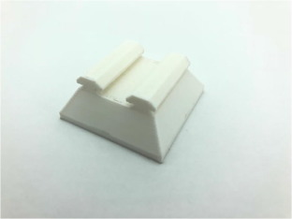

1. [Download : Download high-res image (19KB)](https://ars.els-cdn.com/content/image/1-s2.0-S2468067219300483-gr1_lrg.jpg)
2. [Download : Download full-size image](https://ars.els-cdn.com/content/image/1-s2.0-S2468067219300483-gr1.jpg)

Fig. 1. TripodConnector2.

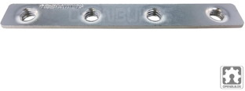

1. [Download : Download high-res image (17KB)](https://ars.els-cdn.com/content/image/1-s2.0-S2468067219300483-gr2_lrg.jpg)
2. [Download : Download full-size image](https://ars.els-cdn.com/content/image/1-s2.0-S2468067219300483-gr2.jpg)

Fig. 2. Quad Tee Nut-MAKERLINK.

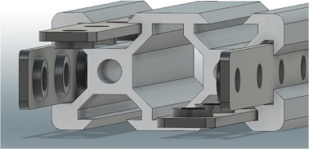

1. [Download : Download high-res image (54KB)](https://ars.els-cdn.com/content/image/1-s2.0-S2468067219300483-gr3_lrg.jpg)
2. [Download : Download full-size image](https://ars.els-cdn.com/content/image/1-s2.0-S2468067219300483-gr3.jpg)

Fig. 3. CAD of the aluminum extrusion and the MAKERKLINKs in their correct locations to minimize the number of the links used. The M5 set screws are not included in the CAD for simplicity.

#### **5.1.3. Motor base assembly**

Press fit the shaft coupler on to the motor until the shaft is flush with the 3D printed part ([Fig. 4](https://www.sciencedirect.com/science/article/pii/S2468067219300483" \l "f0020)). Attach Motor_mount_top to the motor using four M3x8 bolts ([Fig. 5](https://www.sciencedirect.com/science/article/pii/S2468067219300483" \l "f0025)). Attach the other motor mount 3D printed piece, Motor_mount_bottom, using four M5x8 bolt and two double links, to the aluminum beam and place it at the beginning of the ([Fig. 6](https://www.sciencedirect.com/science/article/pii/S2468067219300483" \l "f0030)). Connect the two pieces and bolt them using two M5x8 bolts and the final piece should look like [Fig. 7](https://www.sciencedirect.com/science/article/pii/S2468067219300483" \l "f0035). A video animation of the assembly can be found <https://youtu.be/BjCgw2147VA>.

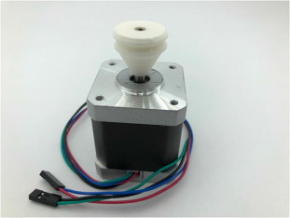

1. [Download : Download high-res image (37KB)](https://ars.els-cdn.com/content/image/1-s2.0-S2468067219300483-gr4_lrg.jpg)
2. [Download : Download full-size image](https://ars.els-cdn.com/content/image/1-s2.0-S2468067219300483-gr4.jpg)

Fig. 4. 3D printed shaft coupler (white piece) mounted on the motor.

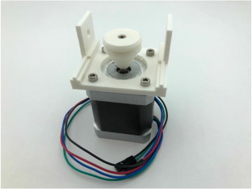

1. [Download : Download high-res image (38KB)](https://ars.els-cdn.com/content/image/1-s2.0-S2468067219300483-gr5_lrg.jpg)
2. [Download : Download full-size image](https://ars.els-cdn.com/content/image/1-s2.0-S2468067219300483-gr5.jpg)

Fig. 5. Motor_mount_top and the shaft coupler attached to motor using M3x8 bolts.

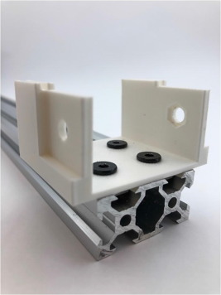

1. [Download : Download high-res image (45KB)](https://ars.els-cdn.com/content/image/1-s2.0-S2468067219300483-gr6_lrg.jpg)
2. [Download : Download full-size image](https://ars.els-cdn.com/content/image/1-s2.0-S2468067219300483-gr6.jpg)

Fig. 6. Motor_mount_bottom attached to the aluminum beam using double links.

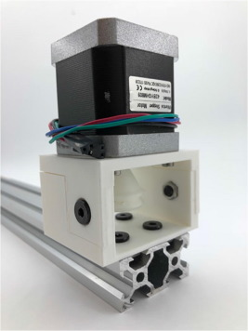

1. [Download : Download high-res image (59KB)](https://ars.els-cdn.com/content/image/1-s2.0-S2468067219300483-gr7_lrg.jpg)
2. [Download : Download full-size image](https://ars.els-cdn.com/content/image/1-s2.0-S2468067219300483-gr7.jpg)

Fig. 7. Finished motor base assembly.

#### **5.1.4. Idle pulley assembly**

First, press fit the IdleRing on to the bearing as shown in [Fig. 8](https://www.sciencedirect.com/science/article/pii/S2468067219300483" \l "f0040). Second, take a LineRollerSpacerTop, [Fig. 9](https://www.sciencedirect.com/science/article/pii/S2468067219300483" \l "f0045)a, and LineRollerSpacerBottom, [Fig. 9](https://www.sciencedirect.com/science/article/pii/S2468067219300483#f0045)b, and press fit them inside the bearing. Third, take an M5x25 bolt and pass it through all three components. The assembly should look like [Fig. 10](https://www.sciencedirect.com/science/article/pii/S2468067219300483" \l "f0050). Fourth, insert four M5x8 bolts in their corresponding orifices on the LineRoller3Base and bolt them on their corresponding double [Fig. 11](https://www.sciencedirect.com/science/article/pii/S2468067219300483" \l "f0055). Last, place LinerRoller3Base on the bolt and tighten the corresponding nut on the assembly. The final product should look like this [Fig. 12](https://www.sciencedirect.com/science/article/pii/S2468067219300483" \l "f0060).

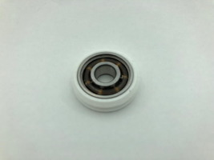

1. [Download : Download high-res image (17KB)](https://ars.els-cdn.com/content/image/1-s2.0-S2468067219300483-gr8_lrg.jpg)
2. [Download : Download full-size image](https://ars.els-cdn.com/content/image/1-s2.0-S2468067219300483-gr8.jpg)

Fig. 8. IdleRing 3D print is press-fit on the ball bearing.

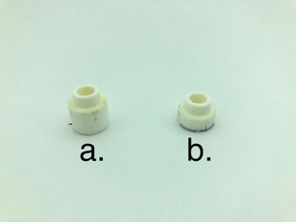

1. [Download : Download high-res image (15KB)](https://ars.els-cdn.com/content/image/1-s2.0-S2468067219300483-gr9_lrg.jpg)
2. [Download : Download full-size image](https://ars.els-cdn.com/content/image/1-s2.0-S2468067219300483-gr9.jpg)

Fig. 9. LineRollerSpacerTop (a) and LineRollerSpacerBottom (b) 3D printed parts.

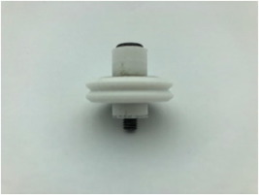

1. [Download : Download high-res image (15KB)](https://ars.els-cdn.com/content/image/1-s2.0-S2468067219300483-gr10_lrg.jpg)
2. [Download : Download full-size image](https://ars.els-cdn.com/content/image/1-s2.0-S2468067219300483-gr10.jpg)

Fig. 10. Top part of the idle pulley assembly.

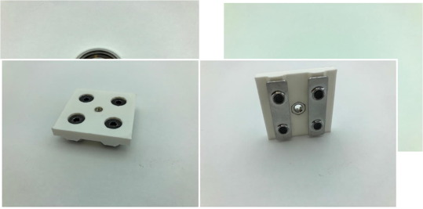

1. [Download : Download high-res image (47KB)](https://ars.els-cdn.com/content/image/1-s2.0-S2468067219300483-gr11_lrg.jpg)
2. [Download : Download full-size image](https://ars.els-cdn.com/content/image/1-s2.0-S2468067219300483-gr11.jpg)

Fig. 11. LineRoller3Base with M5x8 bolts, double tee nuts, and M5 low profile (2.7 mm) nut in the center.

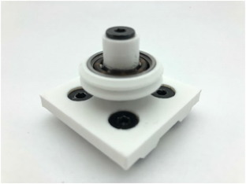

1. [Download : Download high-res image (26KB)](https://ars.els-cdn.com/content/image/1-s2.0-S2468067219300483-gr12_lrg.jpg)
2. [Download : Download full-size image](https://ars.els-cdn.com/content/image/1-s2.0-S2468067219300483-gr12.jpg)

Fig. 12. Completed idle pulley assembly.

#### **5.1.5. Carriage assembly**

An instructional video for the assembly of the carriage is located here. Make sure to add the 13.2 mm spacer to the carriage, this will make sure that the carriage has enough clearance for the fiber to run underneath the carriage. After assembling the carriage, proceed with the following instructions. The Line_Tie2 ([Fig. 13](https://www.sciencedirect.com/science/article/pii/S2468067219300483" \l "f0065)) will be added to the carriage so that the fiber can be used in the system. Take two M5x8 bolts and place them through the Line_Tie2 placing it four holes from the edge and center of the aluminum plate with the hook facing the motor side; tighten the bolts with the corresponding nuts. Add an M4x10 through the hole of the Line_Tie2 and add a nut to the bolt but do not tighten it yet. The assembly should look like [Fig. 14](https://www.sciencedirect.com/science/article/pii/S2468067219300483" \l "f0070).

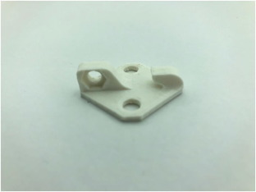

1. [Download : Download high-res image (21KB)](https://ars.els-cdn.com/content/image/1-s2.0-S2468067219300483-gr13_lrg.jpg)
2. [Download : Download full-size image](https://ars.els-cdn.com/content/image/1-s2.0-S2468067219300483-gr13.jpg)

Fig. 13. Line_Tie2 3D printed piece that will have the fiber attached to it.

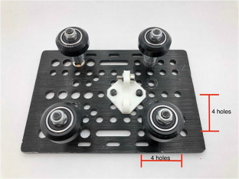

1. [Download : Download high-res image (63KB)](https://ars.els-cdn.com/content/image/1-s2.0-S2468067219300483-gr14_lrg.jpg)
2. [Download : Download full-size image](https://ars.els-cdn.com/content/image/1-s2.0-S2468067219300483-gr14.jpg)

Fig. 14. Line_Tie2 3D printed piece has been placed in its corresponding location. It also has an M4x10 bolt that will be used to tighten the fiber once it has been installed.

#### **5.1.6. Fiber winding**

For easier understanding, this part of the assembly will also have a video, located here, demonstrating the process. With the hook of the Line_Tie2 ([Fig. 13](https://www.sciencedirect.com/science/article/pii/S2468067219300483#f0065)) facing away from the stepper motor, insert the carriage on the aluminum extrusion and place it near the end of the rail, the end with the idling pulley. Insert the idle pulley assembly at the end of the rail and tighten it down. Tie a knot around the hook of the Line_Tie2 ([Fig. 13](https://www.sciencedirect.com/science/article/pii/S2468067219300483#f0065)). Keeping everything taught, run the remaining line twice around the shaft coupler and then back to the idling pulley. Wind the remaining line around the bolt on the Line_Tie2′s M4 bolt and then pull on the fiber to make it as tight as possible while tightening the bolt ([Fig. 15](https://www.sciencedirect.com/science/article/pii/S2468067219300483" \l "f0075)).

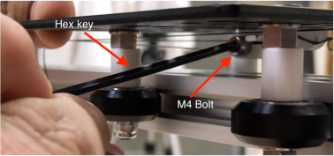

1. [Download : Download high-res image (57KB)](https://ars.els-cdn.com/content/image/1-s2.0-S2468067219300483-gr15_lrg.jpg)
2. [Download : Download full-size image](https://ars.els-cdn.com/content/image/1-s2.0-S2468067219300483-gr15.jpg)

Fig. 15. Fiber tightening on the HyperRail. The hex key is tightening the M4 bolt on which the fiber wraps around.

#### **5.1.7. Electronics wiring**

The wiring of the driver and stepper motor is detailed here on this webpage. The wiring configuration of the HyperRail is summarized in the following lists for a quick setup. Here is a wiring diagram ([Fig. 16](https://www.sciencedirect.com/science/article/pii/S2468067219300483" \l "f0080)) and a list of connections:

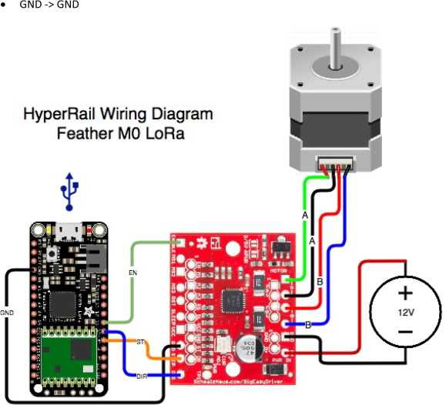

1. [Download : Download high-res image (394KB)](https://ars.els-cdn.com/content/image/1-s2.0-S2468067219300483-gr16_lrg.jpg)
2. [Download : Download full-size image](https://ars.els-cdn.com/content/image/1-s2.0-S2468067219300483-gr16.jpg)

Fig. 16. Wiring diagram of the HyperDrive showing the microcontroller, stepper motor driver, and stepper motor.

Motor → Big Easy Driver

•

Green Wire → A

•

Black Wire → A

•

Red Wire → B

•

Blue Wire → B

Microcontroller → Big Easy Driver

•

Pin 9 → STEP

•

Pin 10 → DIR

•

Pin 11 → ENABLE

•

GND → GND

Barrel Jack → Big Easy Driver

•

V+ → M+

•

GND → GND

When all the wiring is done, it should look like [Fig. 17](https://www.sciencedirect.com/science/article/pii/S2468067219300483" \l "f0085). The feather MO, barrel jack, and Big Easy Driver will all go to inside the electronics enclosure.

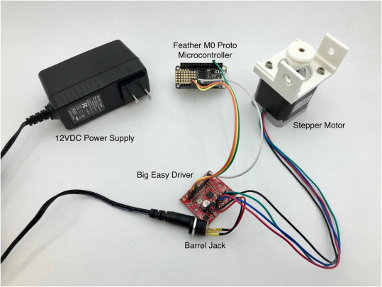

1. [Download : Download high-res image (155KB)](https://ars.els-cdn.com/content/image/1-s2.0-S2468067219300483-gr17_lrg.jpg)
2. [Download : Download full-size image](https://ars.els-cdn.com/content/image/1-s2.0-S2468067219300483-gr17.jpg)

Fig. 17. Wired setup of the HyperRail.

If you start testing the system and the direction of the carriage movement is backwards, swap the wires that are coming from the motor to the Big Easy Driver. In other words, put the wires that go to A in the B location and the wires that go to B now will go to the A location. This is assuming the carriage starts at the side with the motor and it is intended for the carriage to move to the side where the pulley is located.

### 5.2. Three-meter HyperRail vSupraTerra

The assembly process for this version of the HyperRail is very similar to vTerra; the only difference is how the aluminum extrusion is attached to the building structure. The following instructions are for a setup in a typical greenhouse.

#### **5.2.1. Aluminum C channel structure attachment**

Cut the aluminum C channel in sections of 50 mm; for a three-meter HyperRail you will need three. Then, drill out a 12 mm hole on the backbone of the channel. Finally, drill two 6 mm holes centered on the side of the channel spaced 10 mm from the bottom and each other; do the same on the other side. These instructions are visually detailed in [Fig. 18](https://www.sciencedirect.com/science/article/pii/S2468067219300483" \l "f0090).

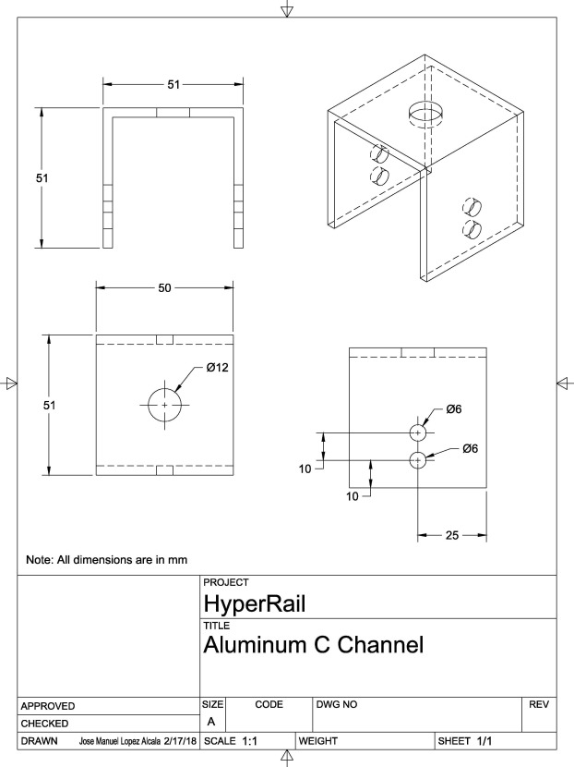

1. [Download : Download high-res image (441KB)](https://ars.els-cdn.com/content/image/1-s2.0-S2468067219300483-gr18_lrg.jpg)
2. [Download : Download full-size image](https://ars.els-cdn.com/content/image/1-s2.0-S2468067219300483-gr18.jpg)

Fig. 18. 2D drawing of the layout of the holes of the aluminum C channel attachments.

After cutting the attachments, begin attaching them on the greenhouse structure starting at the location where the first section of aluminum extrusion will be placed; use an M10 bolt, washer and nut. The next attachments should be space according to the length of the aluminum extrusion. The attachment should resemble [Fig. 19](https://www.sciencedirect.com/science/article/pii/S2468067219300483" \l "f0095).

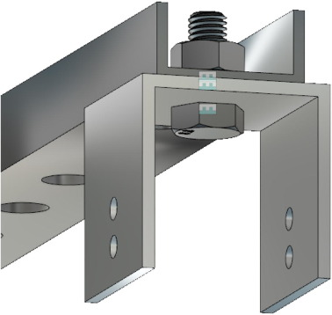

1. [Download : Download high-res image (57KB)](https://ars.els-cdn.com/content/image/1-s2.0-S2468067219300483-gr19_lrg.jpg)
2. [Download : Download full-size image](https://ars.els-cdn.com/content/image/1-s2.0-S2468067219300483-gr19.jpg)

Fig. 19. CAD model of aluminum C channel section attached to greenhouse structure using an M10 bolt, washer, and nut.

#### **5.2.2. Aluminum angle bar**

The aluminum angle bar will be used to connect the track to the building structure; this will be used in conjunction with the C channel part from the last section and will set the distance the track hangs from the building structure. The aluminum angle bar can be cut to the necessary length but for the purposes of this example we will cut at a length of 170 mm. There are two versions of this piece, the left and right; both of the pieces will be necessary for this build. Three holes are necessary for this piece. Two holes, 6 mm in diameter, are spaced 10 mm apart from each other and centered from the edge of the aluminum piece orientated the long way with the second hole 16.5 mm from the edge. The third hole is located on the opposing side and on the other flap of the L bar; this one is located 9.75 mm from the edge and 15.31 mm from the edge orientated the long way. These dimensions are for the left L bracket; the right bracket dimensions are similar and are further detailed in the following figures. [Fig. 20](https://www.sciencedirect.com/science/article/pii/S2468067219300483" \l "f0100), [Fig. 21](https://www.sciencedirect.com/science/article/pii/S2468067219300483" \l "f0105) show the appropriate diameters and locations for the holes to be drilled at for both the left and right-angle bars.

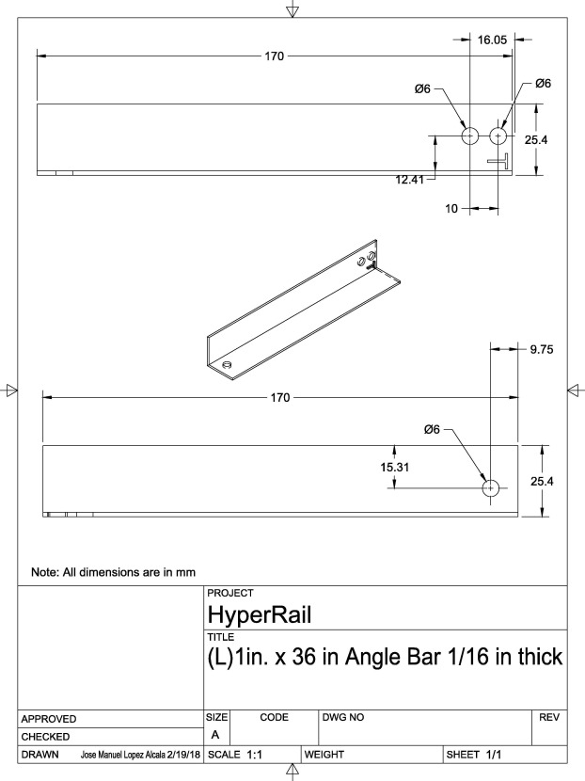

1. [Download : Download high-res image (446KB)](https://ars.els-cdn.com/content/image/1-s2.0-S2468067219300483-gr20_lrg.jpg)
2. [Download : Download full-size image](https://ars.els-cdn.com/content/image/1-s2.0-S2468067219300483-gr20.jpg)

Fig. 20. 2D drawing of left aluminum angle bar. This will be directly attached to the aluminum C channel section.

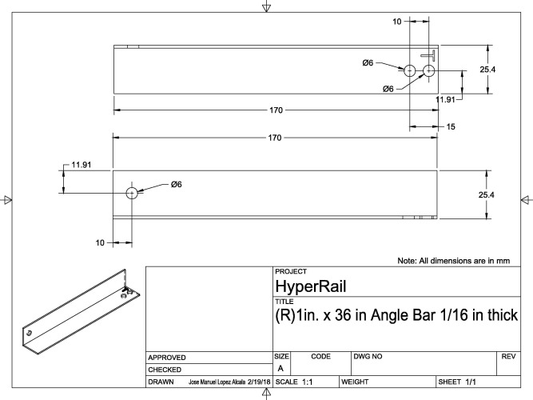

1. [Download : Download high-res image (319KB)](https://ars.els-cdn.com/content/image/1-s2.0-S2468067219300483-gr21_lrg.jpg)
2. [Download : Download full-size image](https://ars.els-cdn.com/content/image/1-s2.0-S2468067219300483-gr21.jpg)

Fig. 21. 2D drawing of right aluminum angle bar. This will be directly attached to the aluminum C channel section.

These angle bars will be attached to the C channel sections in alternating order, i.e. left, right, left, right, etc. Use the M5x10 bolt and corresponding nut to attach the angle bars to the aluminum C channel. The assembly should look similar to [Fig. 22](https://www.sciencedirect.com/science/article/pii/S2468067219300483" \l "f0110).

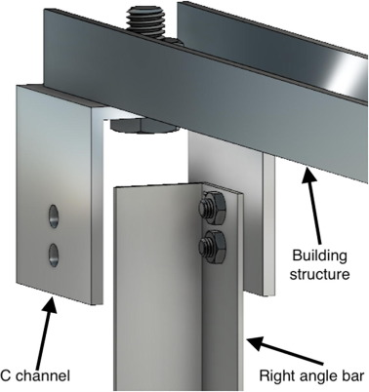

1. [Download : Download high-res image (69KB)](https://ars.els-cdn.com/content/image/1-s2.0-S2468067219300483-gr22_lrg.jpg)
2. [Download : Download full-size image](https://ars.els-cdn.com/content/image/1-s2.0-S2468067219300483-gr22.jpg)

Fig. 22. CAD model of the assembly that includes the C channel and angle bar.

#### **5.2.3. Track assembly**

This section is very similar to the track assembly in [Section 5.1.2](https://www.sciencedirect.com/science/article/pii/S2468067219300483" \l "s0040) but it will not use tripod attachments; therefore, this section will not go into detail about the track connections. For reference or clarification go to [Section 5.1.2](https://www.sciencedirect.com/science/article/pii/S2468067219300483#s0040).

Start by attaching an L bracket, using an M5 tee nut and bolt, near the start of the first section of aluminum extrusion but don’t tighten it hard as it might be necessary to move the bracket. See [Fig. 23](https://www.sciencedirect.com/science/article/pii/S2468067219300483" \l "f0115) for reference for the positioning and alignment of the L bracket.

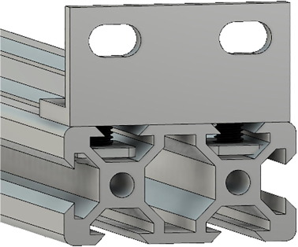

1. [Download : Download high-res image (81KB)](https://ars.els-cdn.com/content/image/1-s2.0-S2468067219300483-gr23_lrg.jpg)
2. [Download : Download full-size image](https://ars.els-cdn.com/content/image/1-s2.0-S2468067219300483-gr23.jpg)

Fig. 23. CAD model of the L bracket attached to the beginning of the aluminum extrusion.

Next, add the MAKERLINKs to the end of the aluminum beam and attach another L bracket directly on the MAKERLINKs using an M5 bolt. The assembly should now look like [Fig. 24](https://www.sciencedirect.com/science/article/pii/S2468067219300483" \l "f0120).

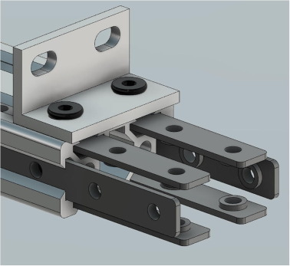

1. [Download : Download high-res image (83KB)](https://ars.els-cdn.com/content/image/1-s2.0-S2468067219300483-gr24_lrg.jpg)
2. [Download : Download full-size image](https://ars.els-cdn.com/content/image/1-s2.0-S2468067219300483-gr24.jpg)

Fig. 24. CAD model of the assembly of the aluminum extrusion with an L bracket attached to the MAKERLINKs.

Now, attach the aluminum beam to the C channel attachments using M5 bolts and the corresponding nuts. [Fig. 25](https://www.sciencedirect.com/science/article/pii/S2468067219300483" \l "f0125) demonstrate the first assembled aluminum beam attached to the building structure.

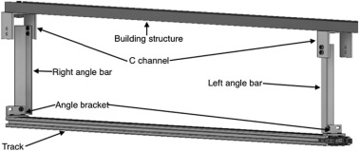

1. [Download : Download high-res image (45KB)](https://ars.els-cdn.com/content/image/1-s2.0-S2468067219300483-gr25_lrg.jpg)
2. [Download : Download full-size image](https://ars.els-cdn.com/content/image/1-s2.0-S2468067219300483-gr25.jpg)

Fig. 25. CAD model of the assembly of the aluminum extrusion attached to the structure of the greenhouse.

For the following aluminum beams, only attach the MAKERLINKs and L bracket at the end. Insert the beam into the one that is already attached to the structure and then bolt it using the MAKERLINK’s bolts and the angle brackets.

### 5.3. Final assembly

Regardless of which version or length of the HyperRail gets implemented, the carriage, stepper motor, and idling pulley will have the same configuration. [Fig. 26](https://www.sciencedirect.com/science/article/pii/S2468067219300483" \l "f0130) is a CAD rendering of a 1-meter version HyperRail showing the complete assembly of the parts previously mentioned.

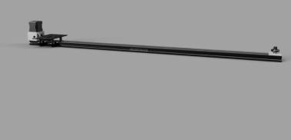

1. [Download : Download high-res image (14KB)](https://ars.els-cdn.com/content/image/1-s2.0-S2468067219300483-gr26_lrg.jpg)
2. [Download : Download full-size image](https://ars.els-cdn.com/content/image/1-s2.0-S2468067219300483-gr26.jpg)

Fig. 26. CAD assembly of 1-meter HyperRail demonstrating the assembly of the carriage, motor, and idling pulley.

The actual implementation of the HyperRail will either be on tripods or connected to a structure of the building and the carriage will either be facing up or down, respectively.

[Fig. 27](https://www.sciencedirect.com/science/article/pii/S2468067219300483" \l "f0135) is the back view, the end that has the idling pulley, and it demonstrates the alignment of the pulleys and wheels on the track. In addition to that, it also displays the positioning of the MAKERLINKS that connect the two pieces of aluminum extrusion; these links are also used to connect the idling pulley base to the end of the aluminum extrusion.

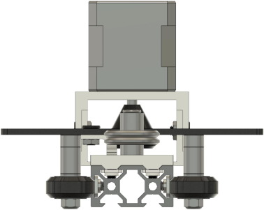

1. [Download : Download high-res image (64KB)](https://ars.els-cdn.com/content/image/1-s2.0-S2468067219300483-gr27_lrg.jpg)
2. [Download : Download full-size image](https://ars.els-cdn.com/content/image/1-s2.0-S2468067219300483-gr27.jpg)

Fig. 27. This CAD model illustrates the positioning of the wheels with respect to the rail. The design of the wheels was created so that they could roll on the aluminum without running into the MAKERLINKs or the bolts that hold them in place.

## 6. Operation instructions

### 6.1. Software download

Download and install both Processing and Arduino IDE’s if the software is not already installed on the computer. After installing the software, download the Arduino and Processing files listed in the last two rows of the design file summaries list; these are the source files, also linked here, that are required for the graphical user interface and the firmware that runs on the microcontroller.

### 6.2. Loading firmware on microcontroller

Loading the firmware on to the microcontroller will be done by using the Arduino IDE. First open the ino file, connect the microcontroller, and then under Tools > Port select the port that indicates the microcontroller, in this case it would be the Adafruit Feather M0.

[Fig. 28](https://www.sciencedirect.com/science/article/pii/S2468067219300483" \l "f0140) shows where to find the tools menu and the ports available. If for some reasons the board is not appearing in the ports list, give your computer a couple seconds before checking again. After selecting the correct port, upload the firmware to the microcontroller by pressing the upload button that has a right-facing-blue arrow inside a white circle in the upper left corner. After uploading the firmware to the microcontroller, the Arduino IDE console should say “Done uploading” ([Fig. 29](https://www.sciencedirect.com/science/article/pii/S2468067219300483" \l "f0145)).

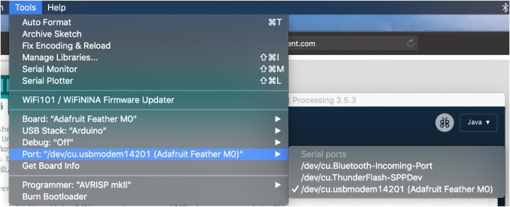

1. [Download : Download high-res image (125KB)](https://ars.els-cdn.com/content/image/1-s2.0-S2468067219300483-gr28_lrg.jpg)
2. [Download : Download full-size image](https://ars.els-cdn.com/content/image/1-s2.0-S2468067219300483-gr28.jpg)

Fig. 28. Tools drop down menu for the Arduino IDE showing the selection of the port to be able to upload the firmware to the microcontroller.

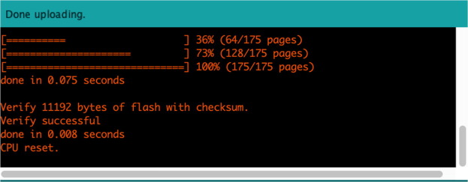

1. [Download : Download high-res image (102KB)](https://ars.els-cdn.com/content/image/1-s2.0-S2468067219300483-gr29_lrg.jpg)
2. [Download : Download full-size image](https://ars.els-cdn.com/content/image/1-s2.0-S2468067219300483-gr29.jpg)

Fig. 29. Arduino IDE console show that successful upload of the firmware to the microcontroller.

The console might have orange text in the black area, but that is not a reason for concern. This text is just extra information that the compiler is supplying for the programmer. At this point, everything should be configured properly on the microcontroller side.

### 6.3. Loading graphical user interface

The first time that the user interface file is run on the Processing IDE it will produce an error ([Fig. 30](https://www.sciencedirect.com/science/article/pii/S2468067219300483" \l "f0150)).

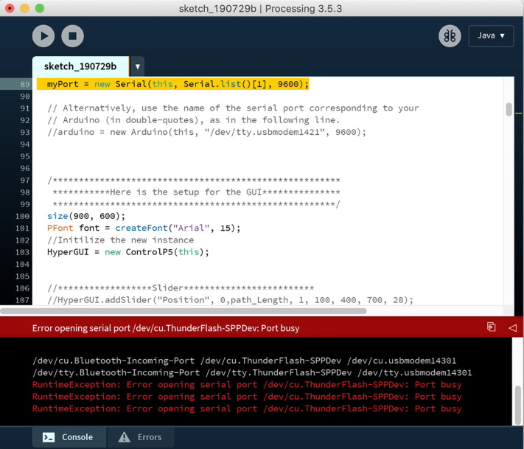

1. [Download : Download high-res image (297KB)](https://ars.els-cdn.com/content/image/1-s2.0-S2468067219300483-gr30_lrg.jpg)
2. [Download : Download full-size image](https://ars.els-cdn.com/content/image/1-s2.0-S2468067219300483-gr30.jpg)

Fig. 30. Processing IDE running the graphical user interface for the first time and producing a communication error.

The way to fix this problem is by changing the number “1” in line 89 to the corresponding port number on which the microcontroller is connected to. What this does is select the serial port through which the graphical user interface is expecting the microcontroller to communicate through. The indexing starts at zero and goes up sequentially looking for all the possible connected devices to the computer. In this example the device at index zero is “dev/cu.Bluetooth-Incoming-Port” and “/dev/cu.ThunderFlash-SPPDev” located at index one and so forth; this is shown in [Fig. 31](https://www.sciencedirect.com/science/article/pii/S2468067219300483" \l "f0155) with a blue number. Setting the correct index will require to locate the device that contains “cu.usbmodem” followed by some number that indicates the port on the computer.

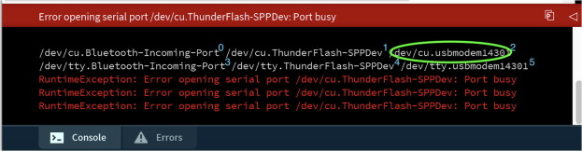

1. [Download : Download high-res image (124KB)](https://ars.els-cdn.com/content/image/1-s2.0-S2468067219300483-gr31_lrg.jpg)
2. [Download : Download full-size image](https://ars.els-cdn.com/content/image/1-s2.0-S2468067219300483-gr31.jpg)

Fig. 31. Processing serial port with list of potential serial ports for incoming devices enumerated starting from zero.

In this example, the port that needs to be selected is “dev/cu.usbmodem14301” and this will tell the graphical user interface that this port will be used to communicate with the microcontroller. To select the port, change line 89 to “myPort = new Serial(this, Serial.list()[[2]](https://www.sciencedirect.com/science/article/pii/S2468067219300483" \l "b0010), 9600)”. The difference here is the number “2”, it replaced number “1”. After this change, re-run the graphical user interface and the console should say “GUI setup complete.” ([Fig. 32](https://www.sciencedirect.com/science/article/pii/S2468067219300483" \l "f0160)).

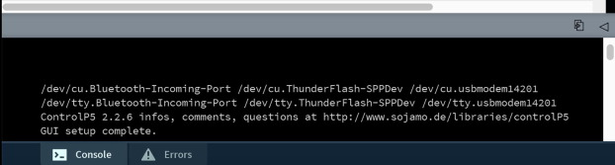

1. [Download : Download high-res image (70KB)](https://ars.els-cdn.com/content/image/1-s2.0-S2468067219300483-gr32_lrg.jpg)
2. [Download : Download full-size image](https://ars.els-cdn.com/content/image/1-s2.0-S2468067219300483-gr32.jpg)

Fig. 32. Graphical user interface console output when the port has been properly selected.

At this point the graphical user interface is complete and should be ready to go. [Fig. 33](https://www.sciencedirect.com/science/article/pii/S2468067219300483" \l "f0165) shows the graphical user interface when it is up and running.

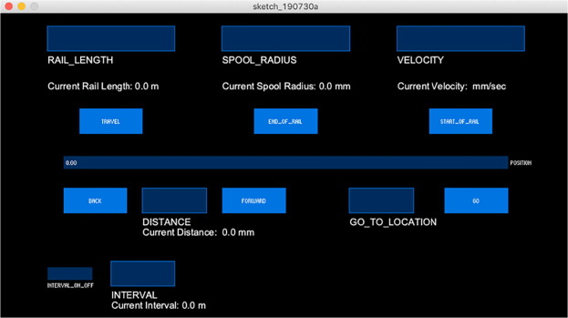

1. [Download : Download high-res image (86KB)](https://ars.els-cdn.com/content/image/1-s2.0-S2468067219300483-gr33_lrg.jpg)
2. [Download : Download full-size image](https://ars.els-cdn.com/content/image/1-s2.0-S2468067219300483-gr33.jpg)

Fig. 33. Graphical user interface successfully running.

After having the firmware uploaded on the microcontroller and the graphical user interface running the system is ready to be used.

### 6.4. Getting started with HyperRail

First, make sure the HyperRail is powered on. This is indicated with an LED light on the stepper motor driver. The next step is to determine and enter the input parameters; 1) rail length [m], 2) spool radius [mm], and 3) velocity [mm/s] in the graphical user interface. There are three options for the direction of movement of the carriage; 1) travel, a return flight, 2) to the end of rail, and 3) to the start of the rail. Once you hit on the three options the carriage will start moving. During the first trial runs keep an eye on the carriage. It is possible that the carriage is obstructed by manufacturing errors such as a faulty connector between the metal extrusions or wrong assembly of the fiber line. If the carriage is obstructed the fiber line will slip on the wheel of the motor base. There are no known safety hazards.